# Attendance Via Face Recognition System Design Document

# Revision History

|  |  |  |  |
| --- | --- | --- | --- |
| **Version** | **Date** | **Author(s)** | **Description** |
| V1.0 | 15/10/2019 | Team | Initial version |

Table of Contents

1Introduction 1

1.1Design Overview 1

1.2Intended Audience 2

1.3References 2

2Detailed Design 2

2.1Architecture 2

Components 3

Interfaces 3

2.2Algorithms and Data Structures 3

2.3External Data 3

Databases 3

Files 3

2.4Performance 4

2.5Test Scripts 4

2.6Miscellaneous 4

3Appendix A

# Introduction:

We are a team of 5 members and as part of our course “Large Application Practicum” are working on Software Development Project via building an mobile and web app which aims to introduce attendance marking system in which faculties will be having this app in their mobile phone and students will mark attendance by face recognition via this app. On working this project, we challenged ourselves and learnt a lot that would benefit us in our future projects.

## **Design Overview:**

The *Attendance via Face Recognition mobile app* is based on Facebook’s platform React-Native and Gradle for development purpose. React-Native is JavaScript framework for writing real, native apps for Android and iOS. It also exposes

JavaScript interfaces for platform APIs so we can use features like phone camera or location. It is an easy to use app for all students and faculties.

## **Intended Audience:**

This document is intended for software developers, coders and testers.

## **References:**

### React-Native: A framework for building native apps using React accessed on 9/10/2019 <https://facebook.github.io/react-native/>

1. Gradle Build Tool for development purposes -: <https://gradle.org/>

# Detailed Design:

This is an Android Application which will be installed on faculty’s smartphone. Faculty will circulate his/her phone to capture the image and student’s attendance will be marked on the Facial Recognition which is done by Keras-OpenFace that will detect face on the camera and check with the student’s database through CNN Training Model of faces which will be process on the server side and when it is matched attendance will be marked. Faculties has to put certain percentage criteria of attendance in the starting and afterwards he/she can check which students are behind this criterion.

**Architecture:** 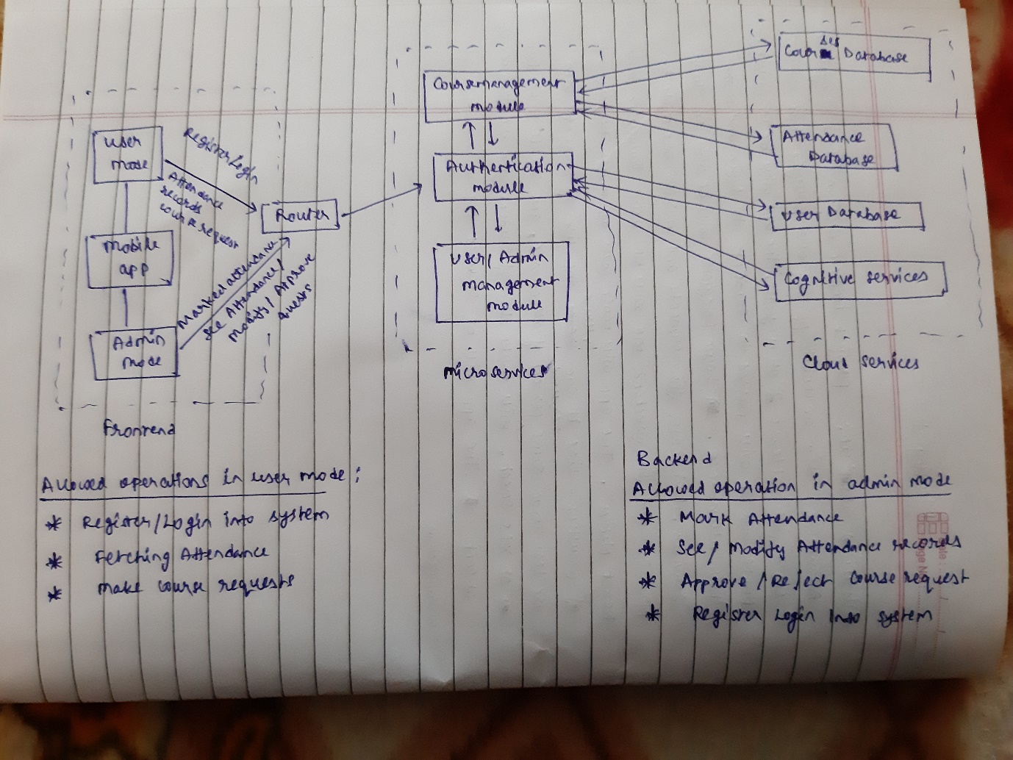

The Face Recognition Architecture is multi-level Web services architecture of React-Native and Nodejs. Frontend will be developed by React-Native for app and Gradle for development while Backend will be developed by Nodejs for server side and JSON Web Token (JWT) for security purpose. Database are on cloud services. All blocks will be developed in this project.

#### **Components:**

1. Faculties access this app either on smartphone or through a browser. Authentication is done by via faculty username and password. The student’s access via their roll no and password. JWT and HTTPS is used for security.
2. React-Native is used for making the scripts for app.

#### **Interfaces:**

The interface between the app and Face recognition system is Keras-OpenFace and CNN training model and between Attendance GUI is XML over HTTPS.

**Algorithms and Data Structures:**

In Face Recognition we are using Keras-OpenFace and training a CNN model for recognising face. We are using hash table for storing information in databases.

**External Data**

**Databases:**

Face Recognition app creates and stores the necessary tables entities. On taking entities from user and faculties and it stores data in separate tables of databases.